**1. Print the numbers from 1 to 10:**

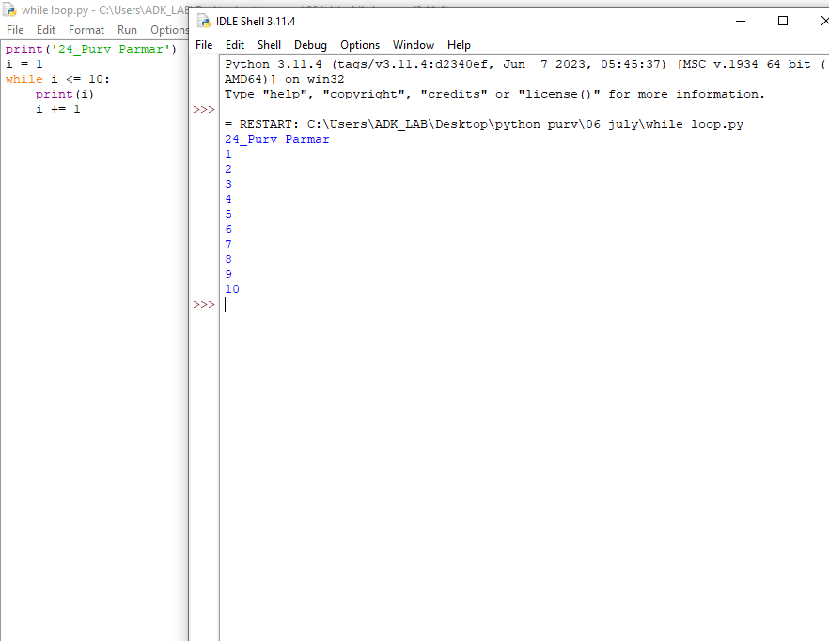

**2. Print the even numbers from 2 to 20:**

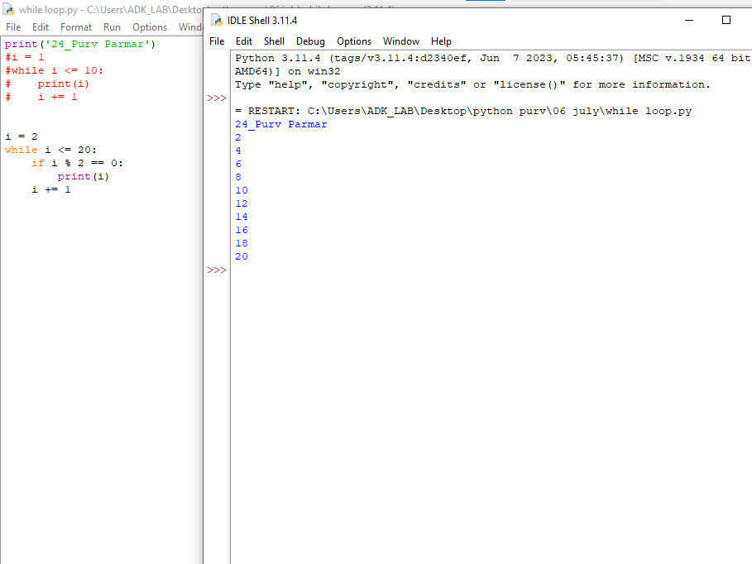

**3. Print the Fibonacci sequence up to the 10th term:**

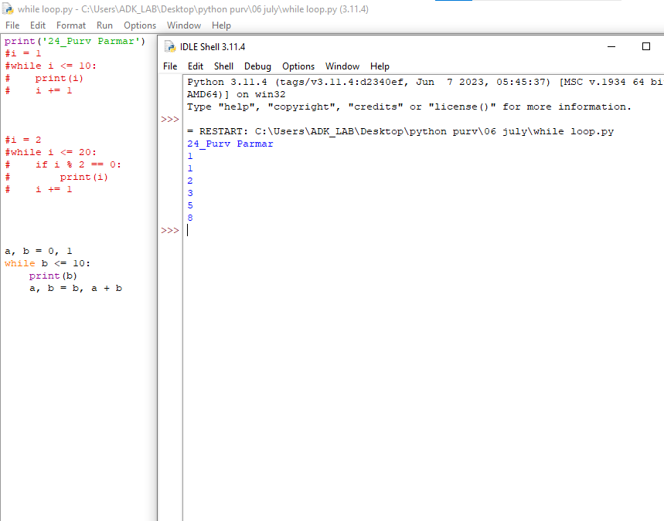

**4. Calculate and print the factorial of 5:**

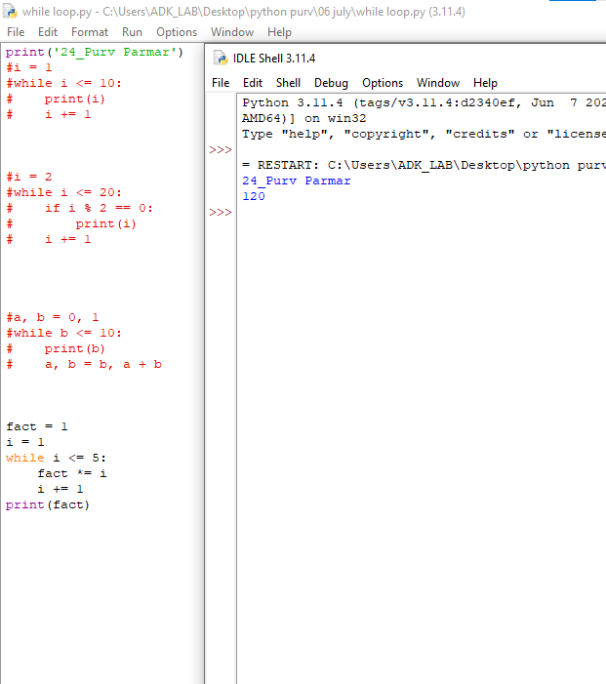

**5. Ask the user to enter a number and print its square:**

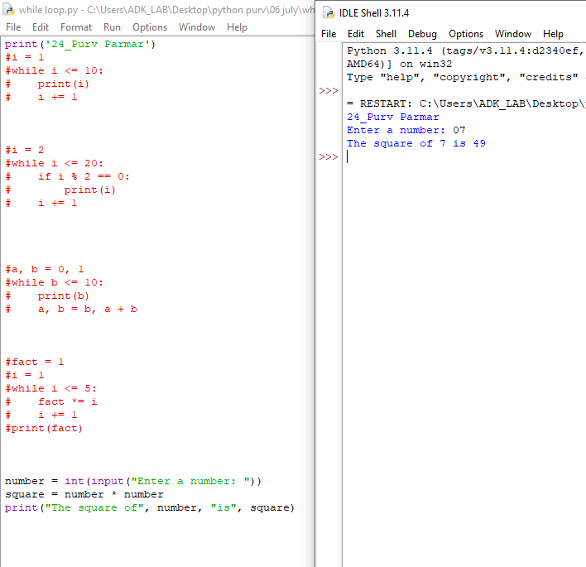

**6. Ask the user to enter a number and print its factorial:**

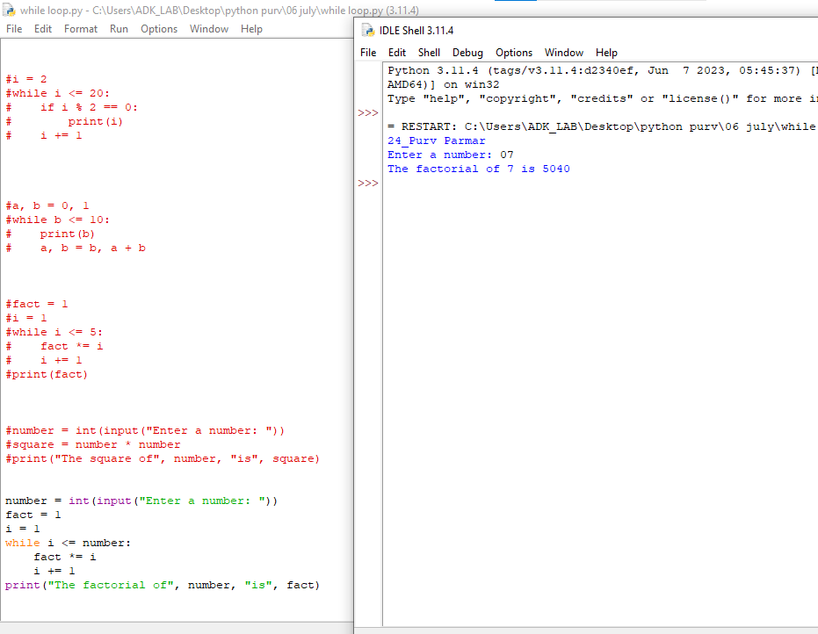

**7. Print the following pattern:**

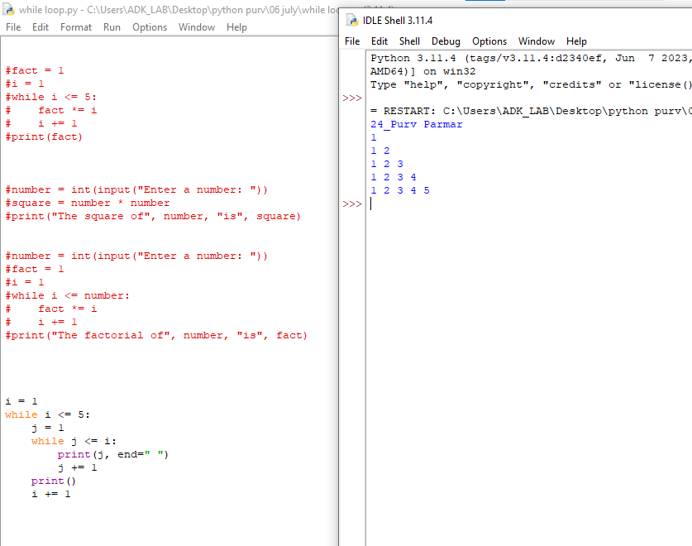

**8. Print the following pattern:**

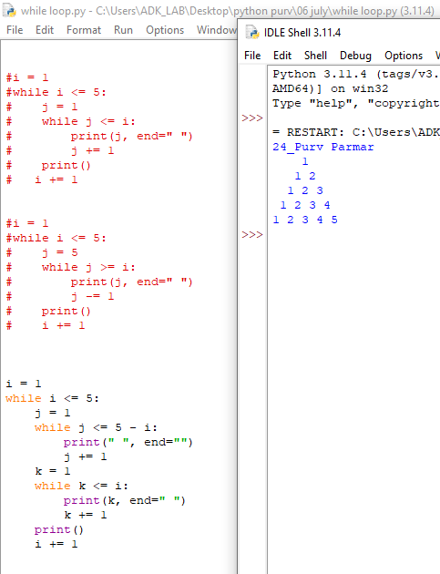

**9. Print the following pattern:**

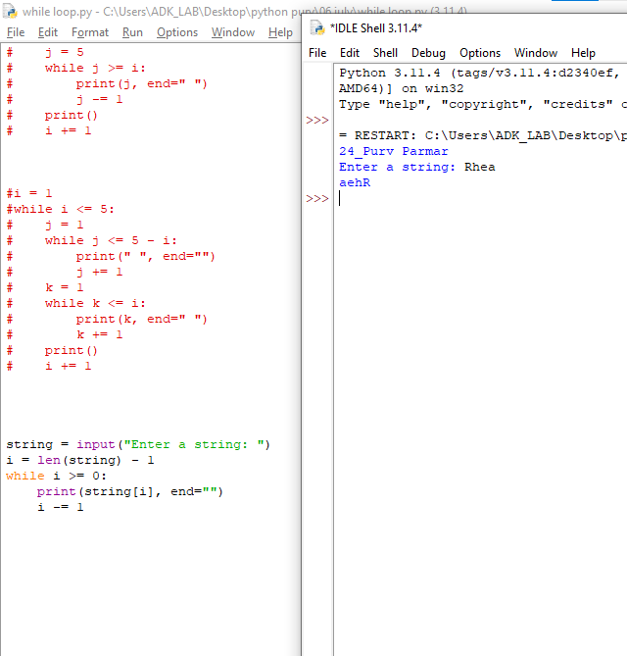

10.Ask the user to enter a string and print it in reverse: